Assignment 12 – Mini Project
Training Institute Management System · B.Sc. Data Science · DTS-202-M (MySQL, database TrainingInstituteDB)

1. Requirement Analysis
Main users:
- Administrator — manages students, trainers, courses, batches and reports.
- Trainer — manages attendance and assessment results.
- Institute Coordinator — reviews batch, attendance, performance and enrollment reports.
Main functional requirements:
- Maintain student and trainer information.
- Maintain courses and batches.
- Enroll students into batches.
- Record attendance for enrollments.
- Record assessment results.
- Generate course, batch, attendance and performance reports.

2. Database Design and Table Relationships
Parent Table | Related Table | Relationship | Purpose
Course | Batch | One-to-Many | One course can have multiple batches.
Trainer | Batch | One-to-Many | One trainer can handle multiple batches.
Student | Enrollment | One-to-Many | One student can have multiple enrollments.
Batch | Enrollment | One-to-Many | One batch can contain multiple enrollments.
Enrollment | Attendance | One-to-Many | One enrollment can have multiple attendance records.
Enrollment | AssessmentResult | One-to-Many | One enrollment can have multiple assessment results.
Basic ER Diagram
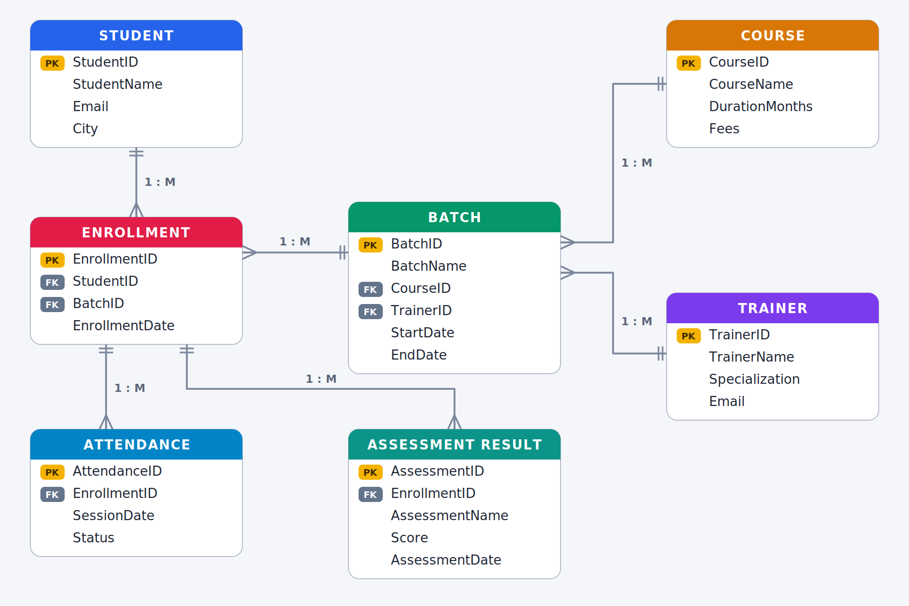
PK = Primary Key · FK = Foreign Key · double bar = “one” side · crow’s foot = “many” side
Database Schema
Table | Column | Data Type | Constraint
Student | StudentID | INT | PRIMARY KEY
Student | StudentName | VARCHAR(50) | NOT NULL
Student | Email | VARCHAR(80) | NULL allowed
Student | City | VARCHAR(30) | NULL allowed
Trainer | TrainerID | INT | PRIMARY KEY
Trainer | TrainerName | VARCHAR(50) | NOT NULL
Trainer | Specialization | VARCHAR(50) | NULL allowed
Trainer | Email | VARCHAR(80) | NULL allowed
Course | CourseID | INT | PRIMARY KEY
Course | CourseName | VARCHAR(50) | NOT NULL
Course | DurationMonths | INT | NOT NULL
Course | Fees | DECIMAL(10,2) | NOT NULL
Batch | BatchID | INT | PRIMARY KEY
Batch | BatchName | VARCHAR(50) | NOT NULL
Batch | CourseID | INT | NOT NULL, FOREIGN KEY → Course(CourseID)
Batch | TrainerID | INT | NOT NULL, FOREIGN KEY → Trainer(TrainerID)
Batch | StartDate | DATE | NOT NULL
Batch | EndDate | DATE | NULL allowed
Enrollment | EnrollmentID | INT | PRIMARY KEY
Enrollment | StudentID | INT | NOT NULL, FOREIGN KEY → Student(StudentID)
Enrollment | BatchID | INT | NOT NULL, FOREIGN KEY → Batch(BatchID)
Enrollment | EnrollmentDate | DATE | NOT NULL
Attendance | AttendanceID | INT | PRIMARY KEY
Attendance | EnrollmentID | INT | NOT NULL, FOREIGN KEY → Enrollment(EnrollmentID)
Attendance | SessionDate | DATE | NOT NULL
Attendance | Status | ENUM('Present','Absent') | NOT NULL
AssessmentResult | AssessmentID | INT | PRIMARY KEY
AssessmentResult | EnrollmentID | INT | NOT NULL, FOREIGN KEY → Enrollment(EnrollmentID)
AssessmentResult | AssessmentName | VARCHAR(50) | NOT NULL
AssessmentResult | Score | DECIMAL(5,2) | NOT NULL
AssessmentResult | AssessmentDate | DATE | NOT NULL

3. Database Creation and Table Structure
3.1 Create the database
CREATE DATABASE TrainingInstituteDB;
USE TrainingInstituteDB;
Output:
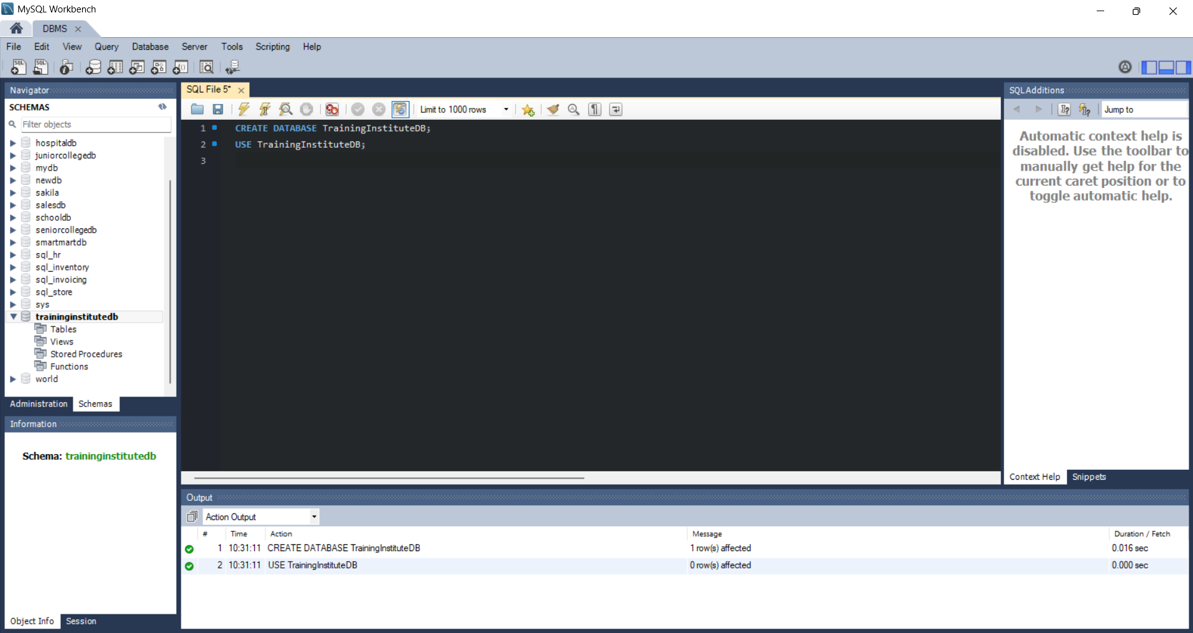
3.2 Student table
CREATE TABLE Student (
StudentID INT PRIMARY KEY,
StudentName VARCHAR(50) NOT NULL,
Email VARCHAR(80),
City VARCHAR(30)
);
Output:
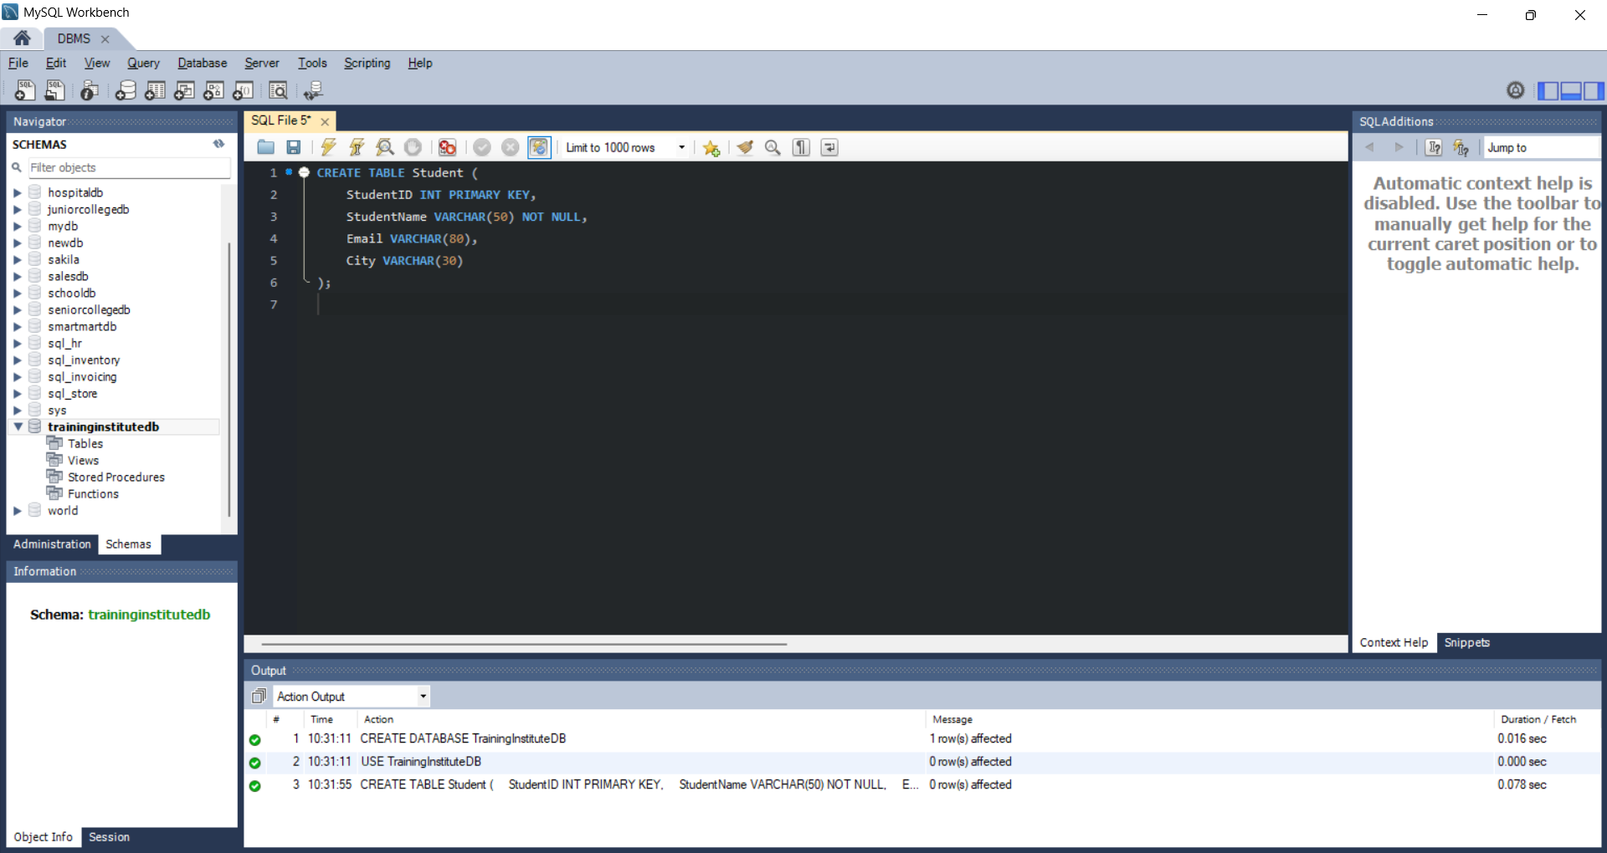
3.3 Trainer table
CREATE TABLE Trainer (
TrainerID INT PRIMARY KEY,
TrainerName VARCHAR(50) NOT NULL,
Specialization VARCHAR(50),
Email VARCHAR(80)
);
Output:
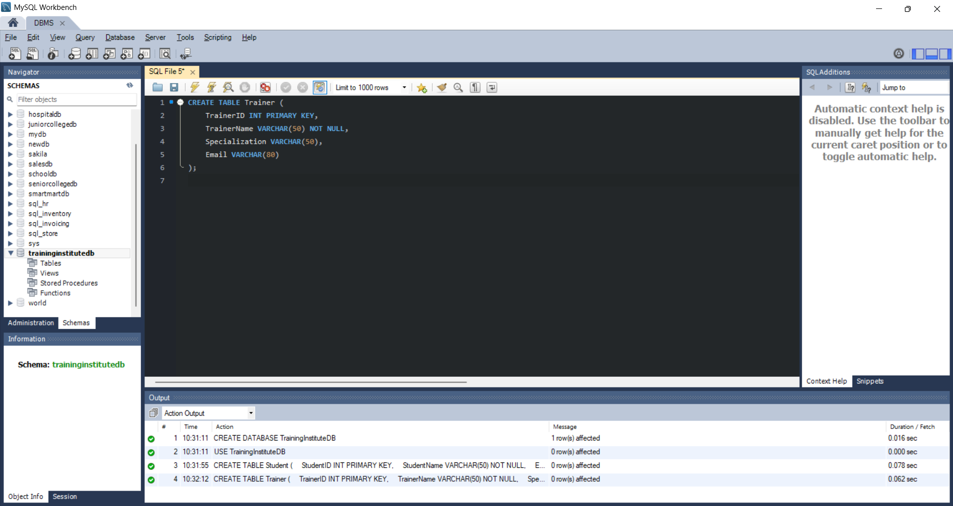
3.4 Course table
CREATE TABLE Course (
CourseID INT PRIMARY KEY,
CourseName VARCHAR(50) NOT NULL,
DurationMonths INT NOT NULL,
Fees DECIMAL(10,2) NOT NULL
);
Output:
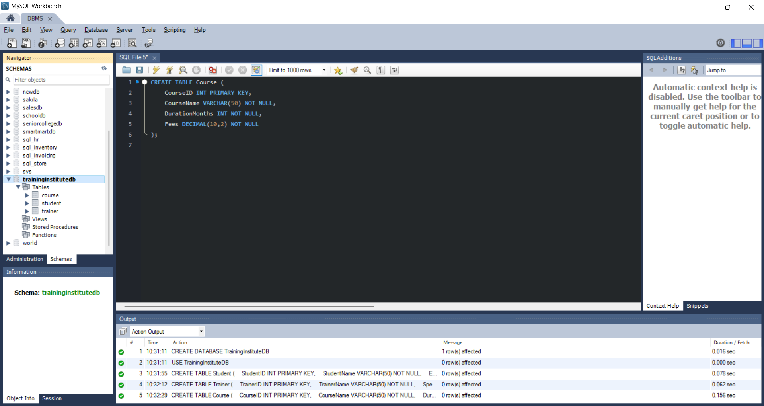
3.5 Batch table
CREATE TABLE Batch (
BatchID INT PRIMARY KEY,
BatchName VARCHAR(50) NOT NULL,
CourseID INT NOT NULL,
TrainerID INT NOT NULL,
StartDate DATE NOT NULL,
EndDate DATE,
FOREIGN KEY (CourseID) REFERENCES Course(CourseID),
FOREIGN KEY (TrainerID) REFERENCES Trainer(TrainerID)
);
Output:
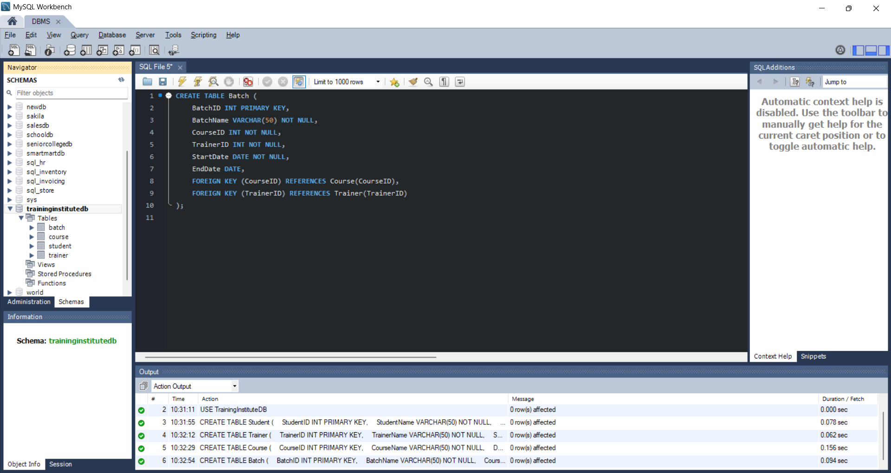
3.6 Enrollment table
CREATE TABLE Enrollment (
EnrollmentID INT PRIMARY KEY,
StudentID INT NOT NULL,
BatchID INT NOT NULL,
EnrollmentDate DATE NOT NULL,
FOREIGN KEY (StudentID) REFERENCES Student(StudentID),
FOREIGN KEY (BatchID) REFERENCES Batch(BatchID)
);
Output:
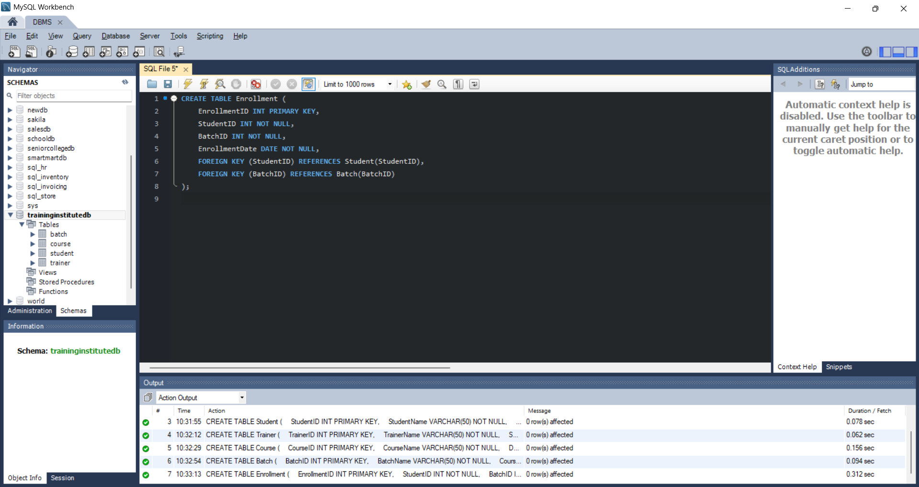
3.7 Attendance table
CREATE TABLE Attendance (
AttendanceID INT PRIMARY KEY,
EnrollmentID INT NOT NULL,
SessionDate DATE NOT NULL,
Status ENUM('Present','Absent') NOT NULL,
FOREIGN KEY (EnrollmentID) REFERENCES Enrollment(EnrollmentID)
);
Output:
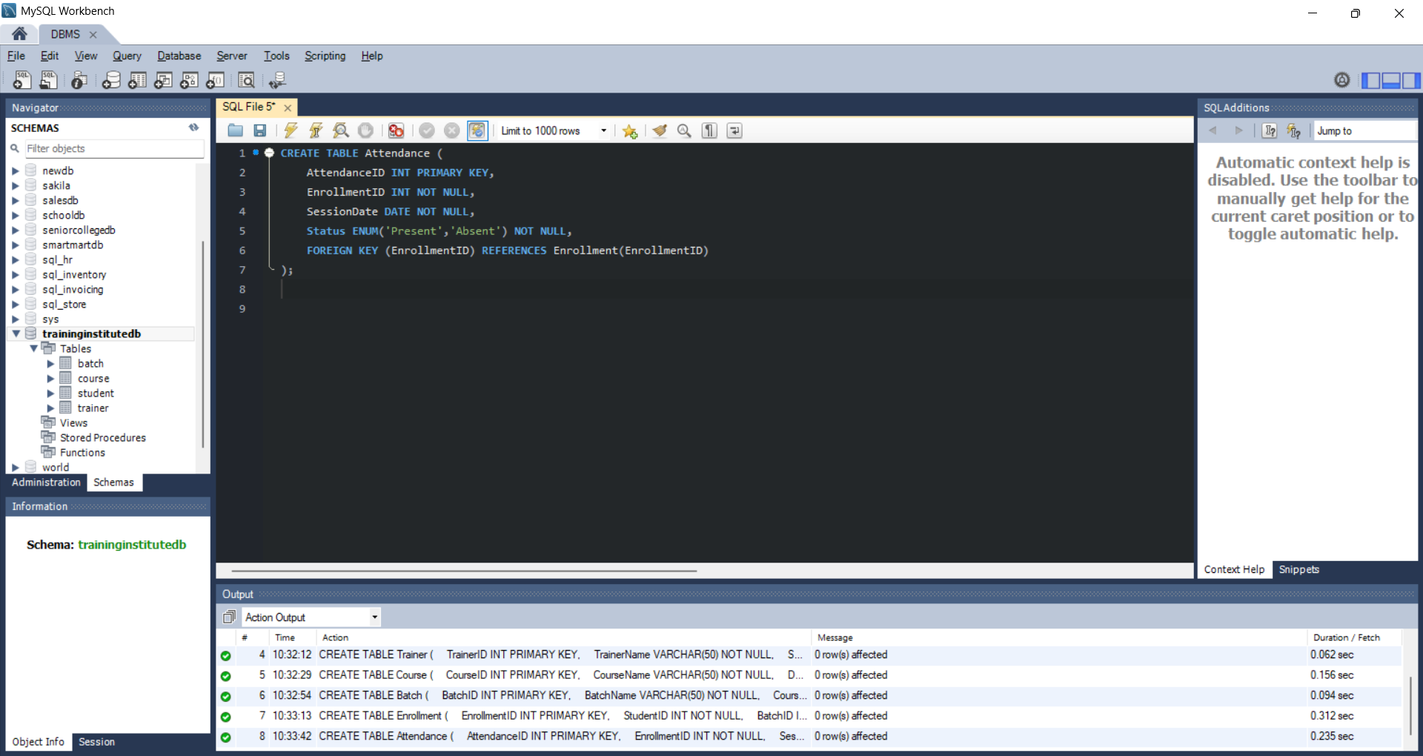
3.8 AssessmentResult table
CREATE TABLE AssessmentResult (
AssessmentID INT PRIMARY KEY,
EnrollmentID INT NOT NULL,
AssessmentName VARCHAR(50) NOT NULL,
Score DECIMAL(5,2) NOT NULL,
AssessmentDate DATE NOT NULL,
FOREIGN KEY (EnrollmentID) REFERENCES Enrollment(EnrollmentID)
);
Output:
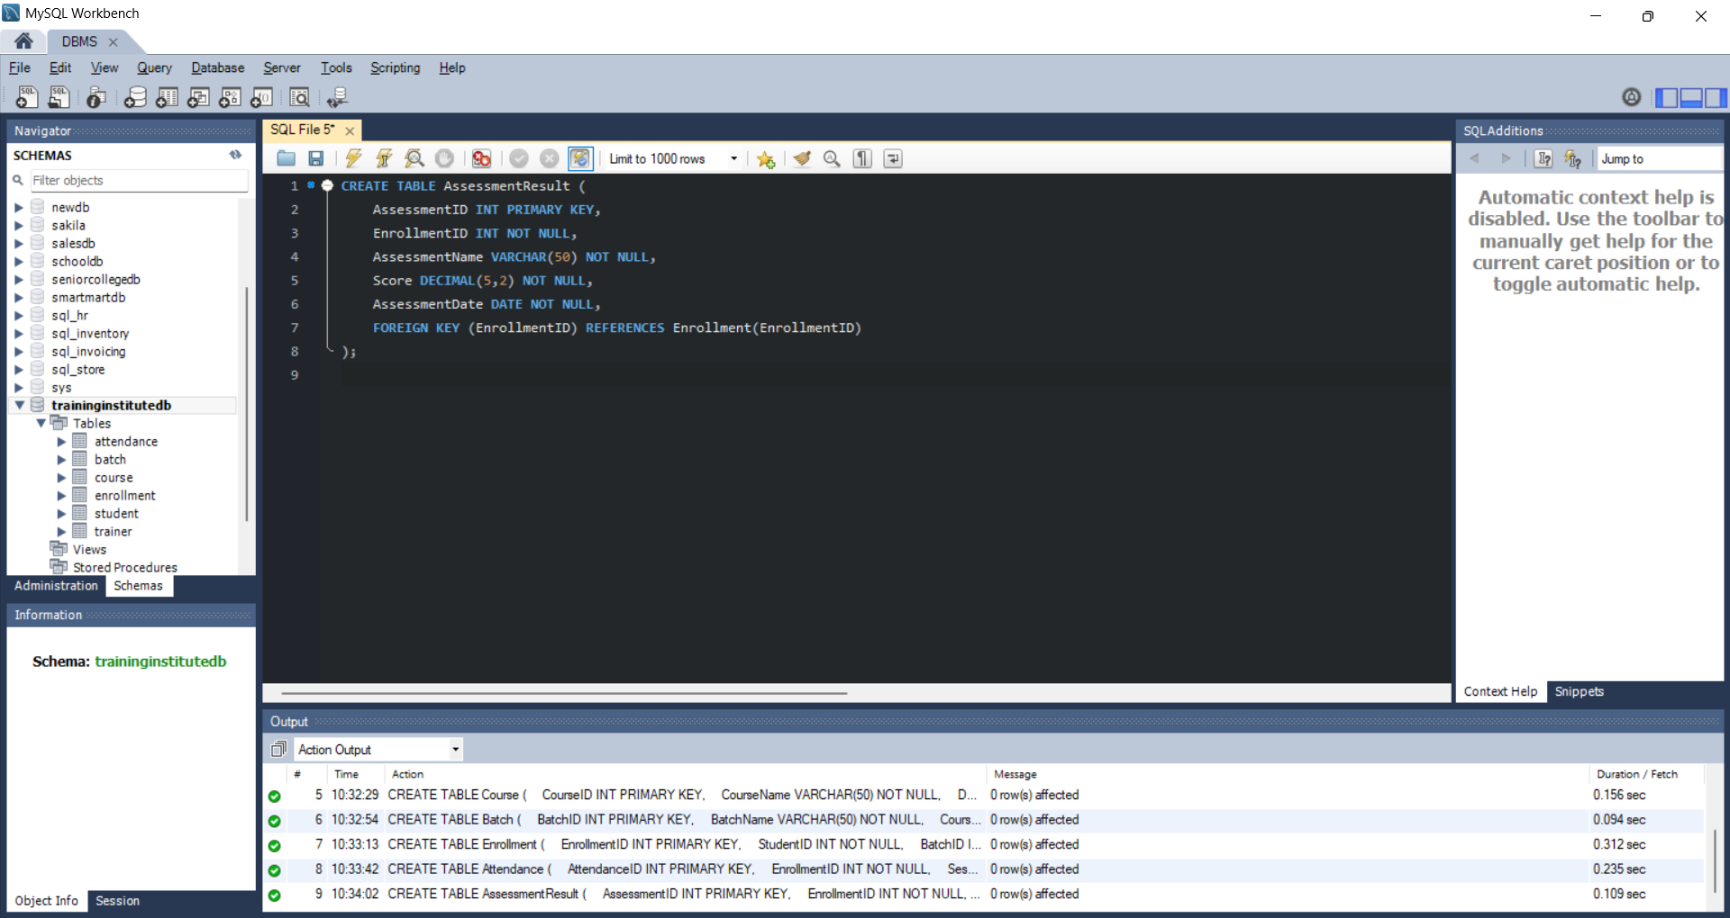

4. Sample Data
4.1 Insert into Student
INSERT INTO Student VALUES
(1,'Rahul Sharma','rahul@gmail.com','Mumbai'),
(2,'Priya Patil','priya@gmail.com','Pune'),
(3,'Aman Verma','aman@gmail.com','Nashik'),
(4,'Sneha Joshi','sneha@gmail.com','Mumbai'),
(5,'Karan Mehta','karan@gmail.com','Thane'),
(6,'Neha Shah','neha@gmail.com','Pune');
Output:
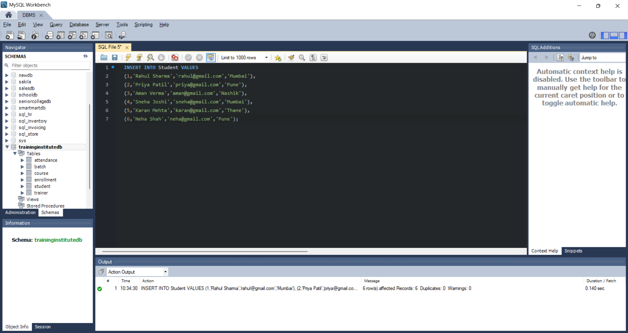
4.2 Insert into Trainer
INSERT INTO Trainer VALUES
(101,'Amit Kulkarni','SQL and Database Management','amit@training.com'),
(102,'Pooja Desai','Python and Data Science','pooja@training.com'),
(103,'Rohan Mehta','Web Development','rohan@training.com');
Output:
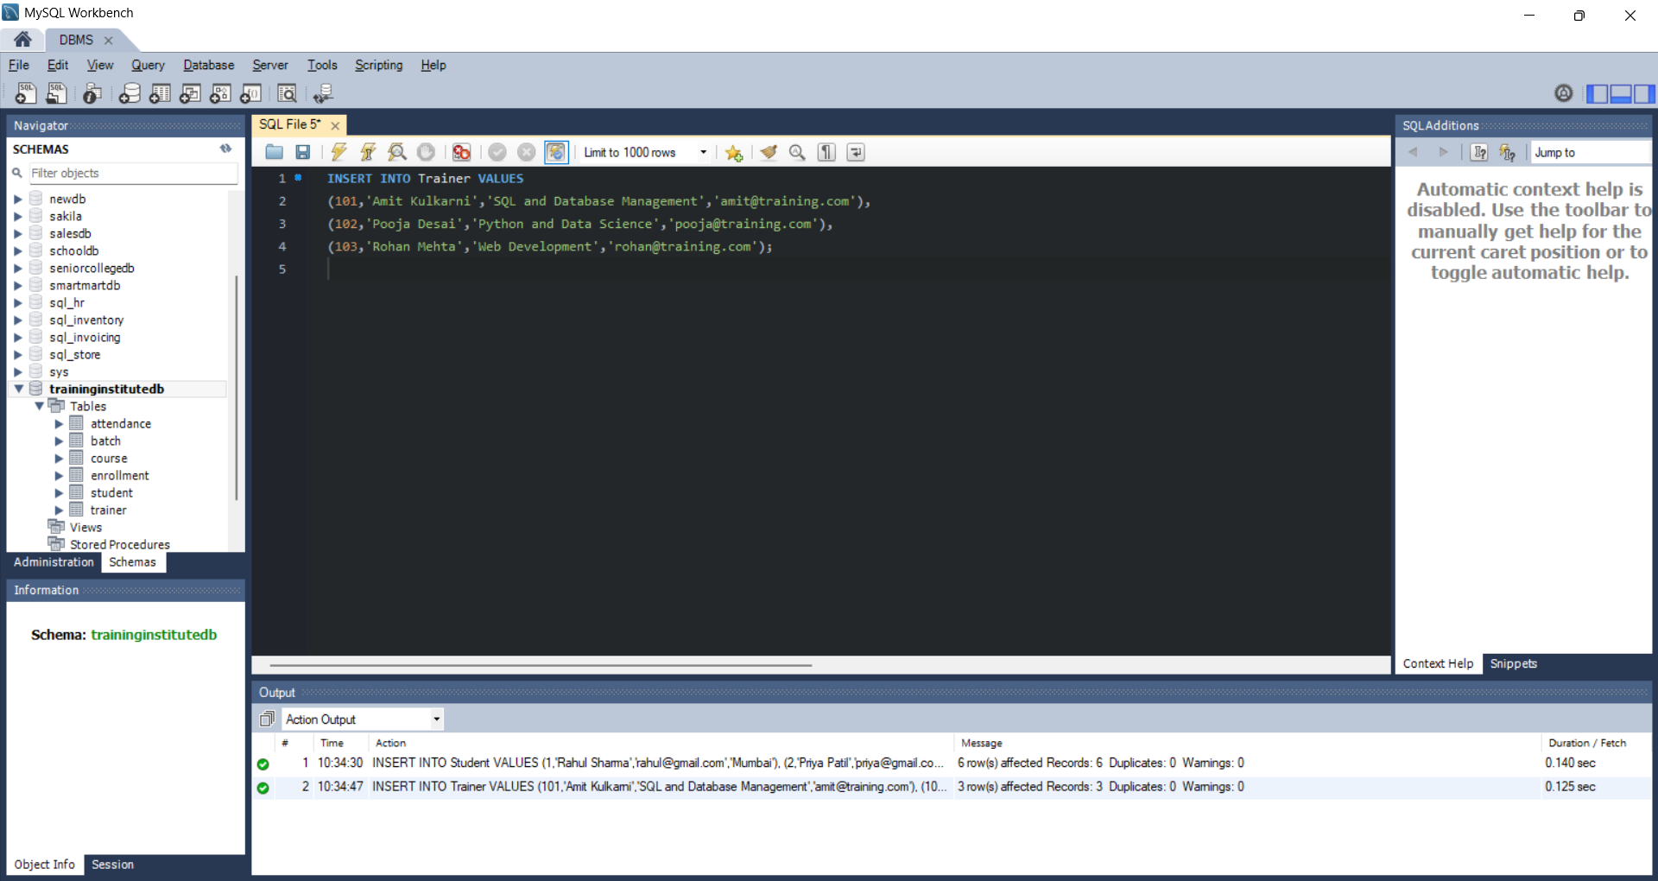
4.3 Insert into Course
INSERT INTO Course VALUES
(201,'SQL and Database Management',3,18000.00),
(202,'Python for Data Science',4,25000.00),
(203,'Web Development',4,22000.00);
Output:
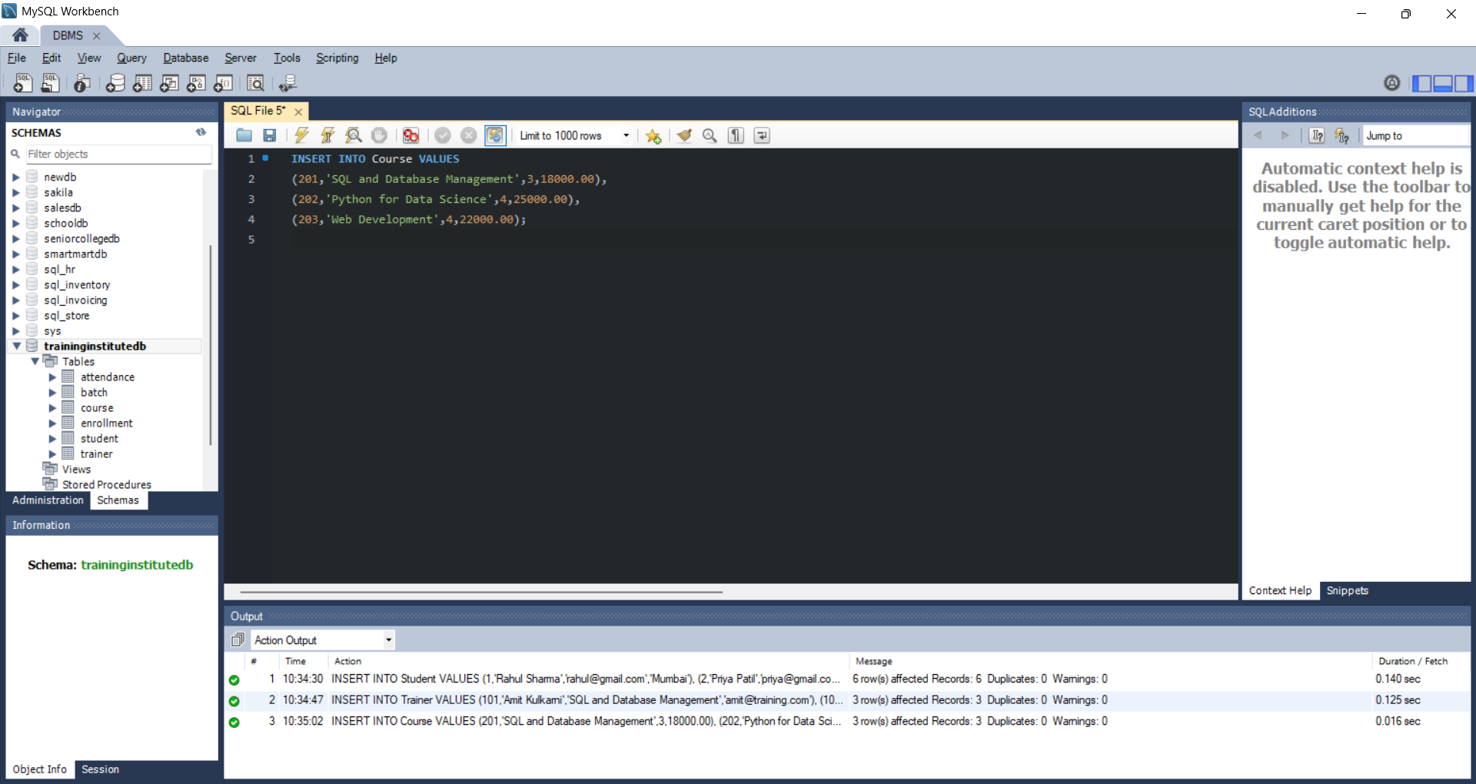
4.4 Insert into Batch
INSERT INTO Batch VALUES
(301,'SQL-MAR-2026',201,101,'2026-03-01','2026-05-31'),
(302,'Python-MAR-2026',202,102,'2026-03-05','2026-06-30'),
(303,'Web-MAR-2026',203,103,'2026-03-10','2026-07-10');
Output:
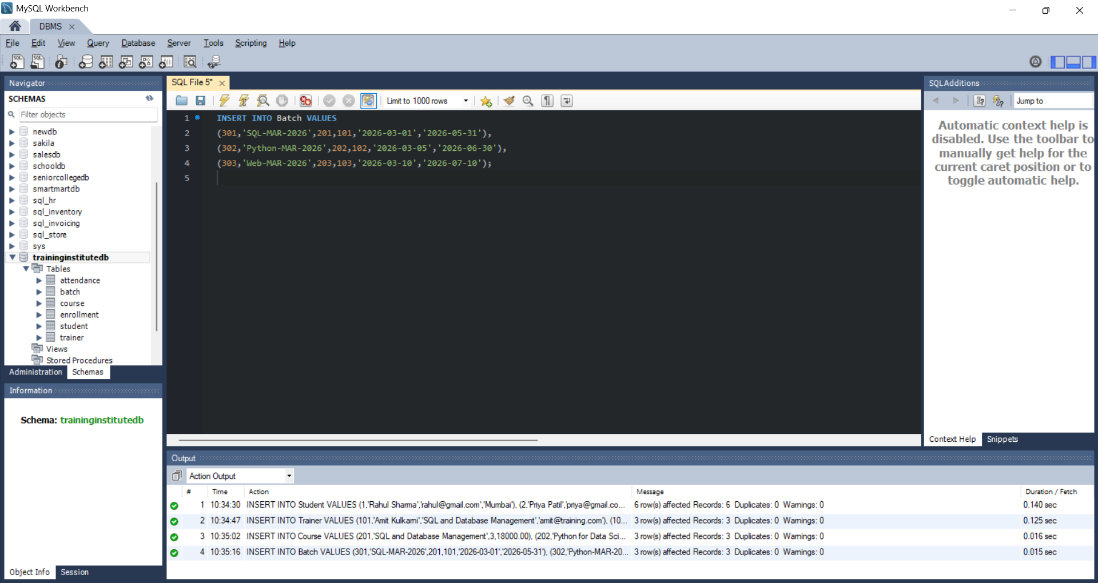
4.5 Insert into Enrollment
INSERT INTO Enrollment VALUES
(401,1,301,'2026-03-01'),
(402,2,301,'2026-03-01'),
(403,3,302,'2026-03-05'),
(404,4,302,'2026-03-05'),
(405,5,303,'2026-03-10'),
(406,6,301,'2026-03-01');
Output:
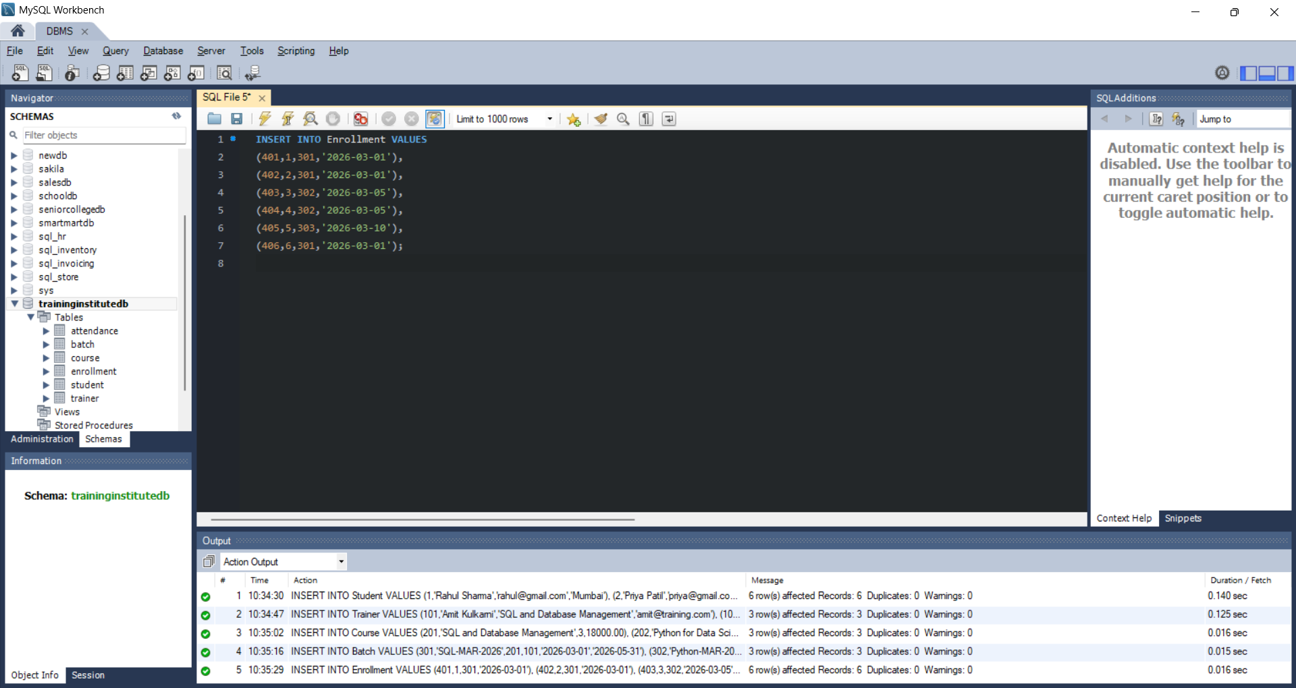
4.6 Insert into Attendance
INSERT INTO Attendance VALUES
(501,401,'2026-03-10','Present'),
(502,401,'2026-03-17','Present'),
(503,402,'2026-03-10','Absent'),
(504,402,'2026-03-17','Present'),
(505,403,'2026-03-10','Present'),
(506,403,'2026-03-17','Present'),
(507,404,'2026-03-10','Absent'),
(508,404,'2026-03-17','Absent'),
(509,405,'2026-03-12','Present'),
(510,405,'2026-03-19','Present'),
(511,406,'2026-03-10','Present'),
(512,406,'2026-03-17','Absent');
Output:
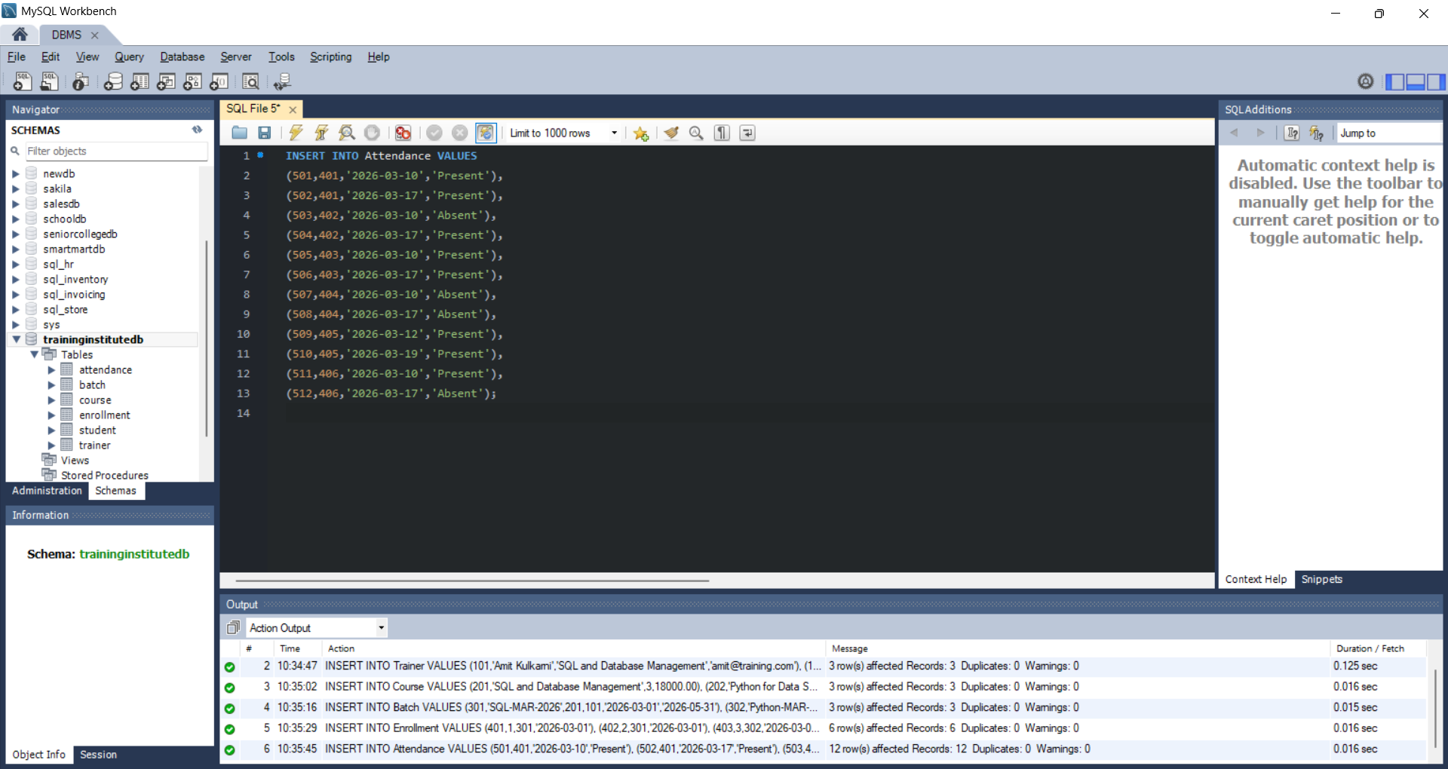
4.7 Insert into AssessmentResult
INSERT INTO AssessmentResult VALUES
(601,401,'SQL Test',88,'2026-04-01'),
(602,402,'SQL Test',76,'2026-04-01'),
(603,403,'Python Test',92,'2026-04-05'),
(604,404,'Python Test',68,'2026-04-05'),
(605,405,'Web Test',84,'2026-04-10'),
(606,406,'SQL Test',81,'2026-04-01');
Output:
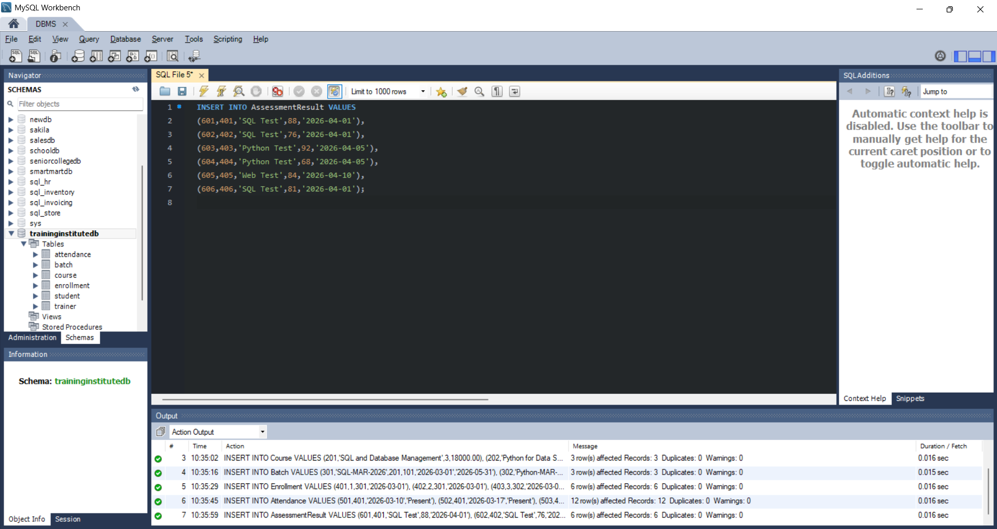

5. Business Queries and Data Analysis
Q1. Display all students enrolled in each batch.
SELECT B.BatchName, S.StudentName
FROM Enrollment E
INNER JOIN Student S ON E.StudentID = S.StudentID
INNER JOIN Batch B ON E.BatchID = B.BatchID
ORDER BY B.BatchName, S.StudentName;
Output:
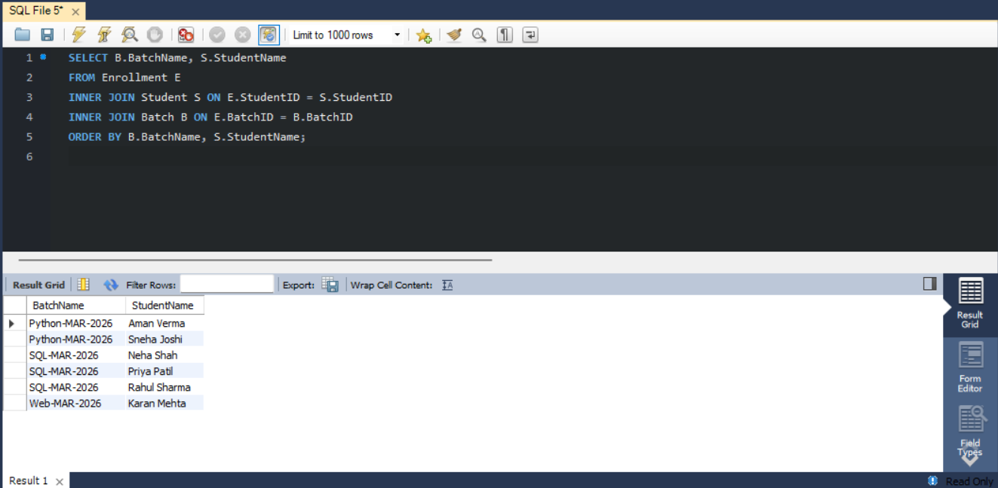
Q2. Display the course and trainer assigned to every batch.
SELECT B.BatchName, C.CourseName, T.TrainerName
FROM Batch B
INNER JOIN Course C ON B.CourseID = C.CourseID
INNER JOIN Trainer T ON B.TrainerID = T.TrainerID;
Output:
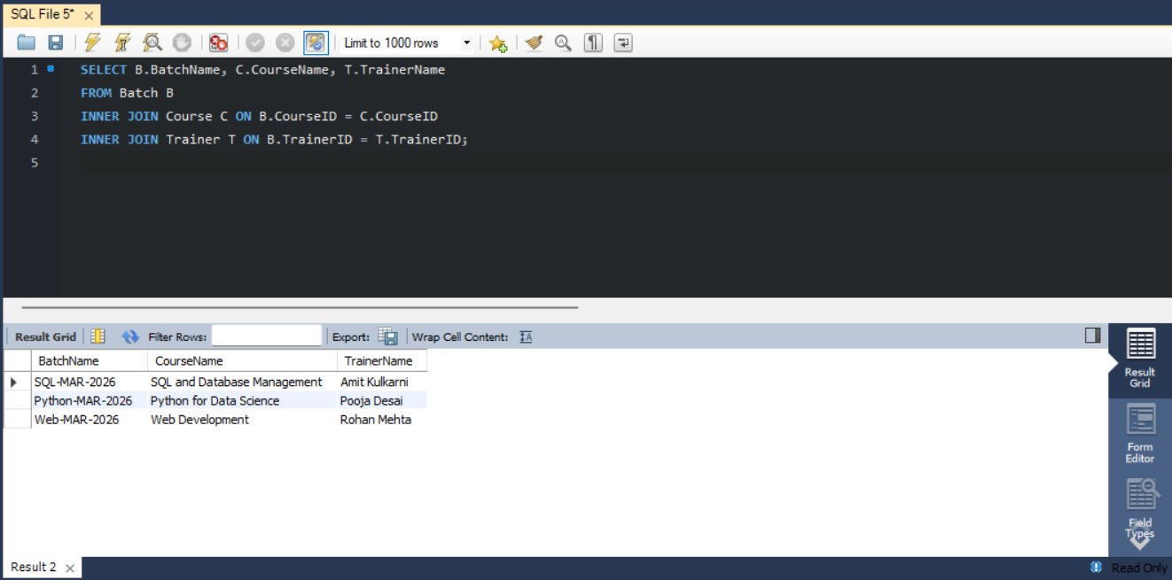
Q3. Find the total number of students in each course.
SELECT C.CourseName, COUNT(E.EnrollmentID) AS TotalStudents
FROM Course C
LEFT JOIN Batch B ON C.CourseID = B.CourseID
LEFT JOIN Enrollment E ON B.BatchID = E.BatchID
GROUP BY C.CourseID, C.CourseName;
Output:
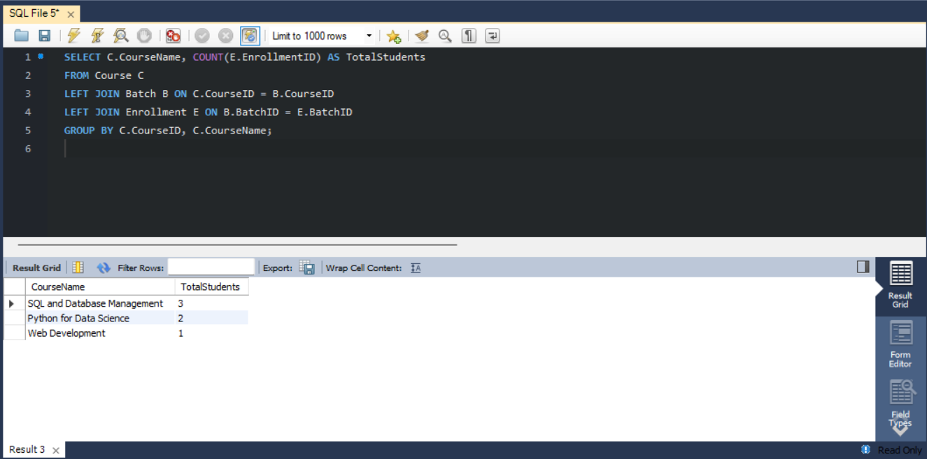
Q4. Find batches having more than a specified number of students.
SELECT B.BatchName, COUNT(E.EnrollmentID) AS TotalStudents
FROM Batch B
LEFT JOIN Enrollment E ON B.BatchID = E.BatchID
GROUP BY B.BatchID, B.BatchName
HAVING COUNT(E.EnrollmentID) > 1;
Note: Change 1 to the required threshold.
Output:
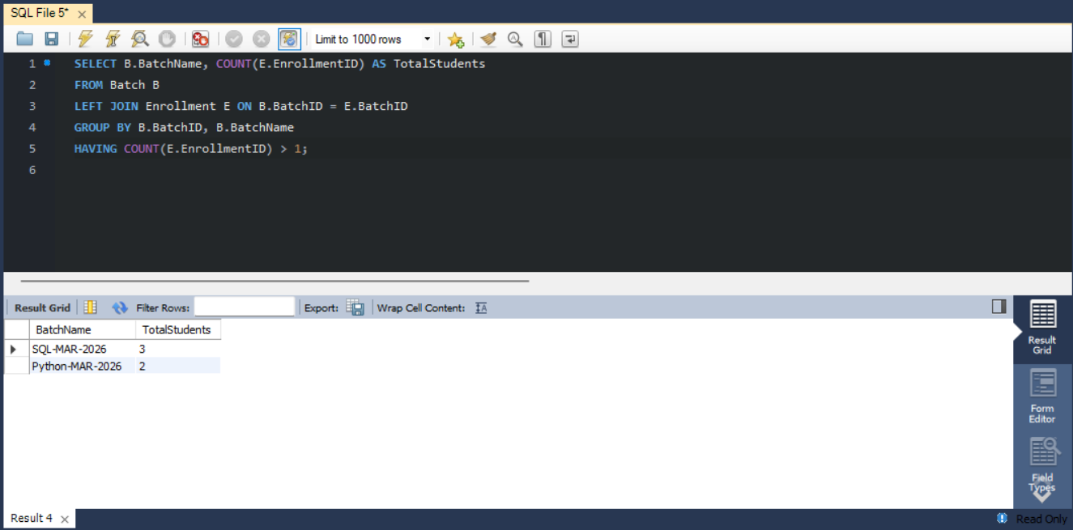
Q5. Display students whose attendance is below 75%.
SELECT S.StudentName,
ROUND(100.0 * SUM(A.Status = 'Present') / COUNT(A.AttendanceID), 2) AS AttendancePercentage
FROM Student S
INNER JOIN Enrollment E ON S.StudentID = E.StudentID
INNER JOIN Attendance A ON E.EnrollmentID = A.EnrollmentID
GROUP BY S.StudentID, S.StudentName
HAVING AttendancePercentage < 75;
Output:
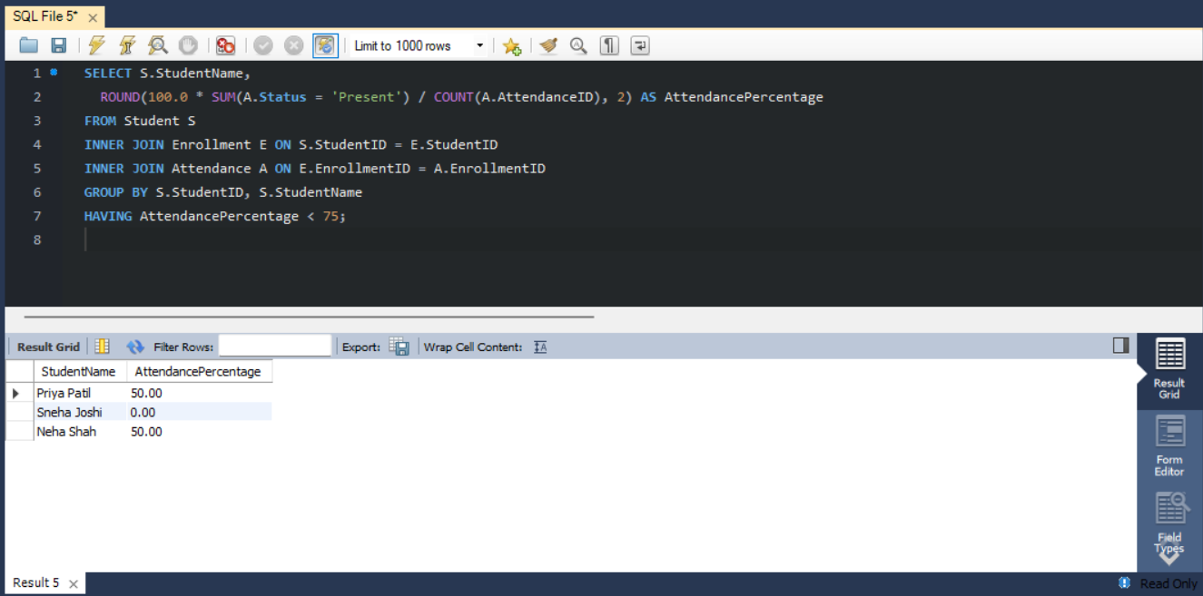
Q6. Find the average assessment score for each batch.
SELECT B.BatchName, ROUND(AVG(A.Score), 2) AS AverageScore
FROM Batch B
INNER JOIN Enrollment E ON B.BatchID = E.BatchID
INNER JOIN AssessmentResult A ON E.EnrollmentID = A.EnrollmentID
GROUP BY B.BatchID, B.BatchName;
Output:
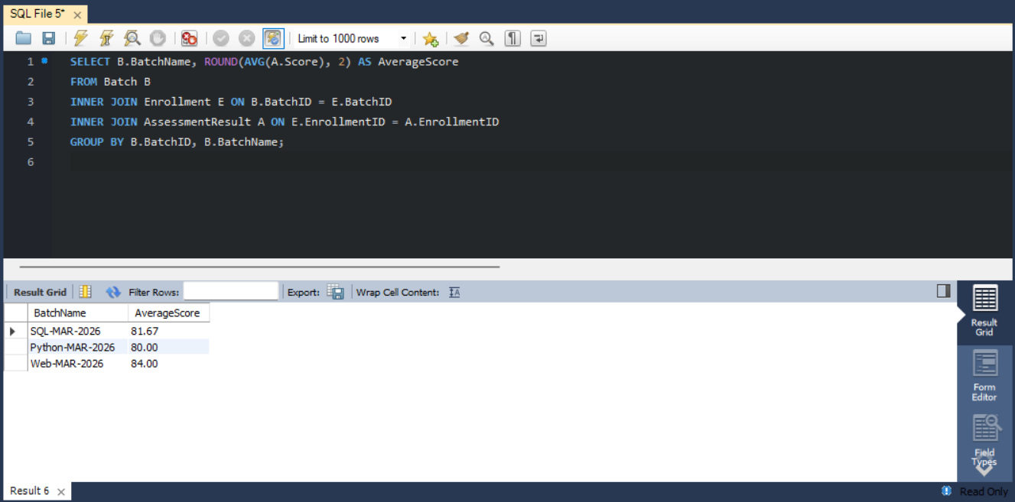
Q7. Identify the highest-performing student in every batch.
SELECT BatchName, StudentName, Score
FROM (
SELECT B.BatchName, S.StudentName, A.Score,
ROW_NUMBER() OVER (PARTITION BY B.BatchID
ORDER BY A.Score DESC, S.StudentID) AS RowNum
FROM AssessmentResult A
INNER JOIN Enrollment E ON A.EnrollmentID = E.EnrollmentID
INNER JOIN Student S ON E.StudentID = S.StudentID
INNER JOIN Batch B ON E.BatchID = B.BatchID
) AS RankedStudents
WHERE RowNum = 1;
Output:
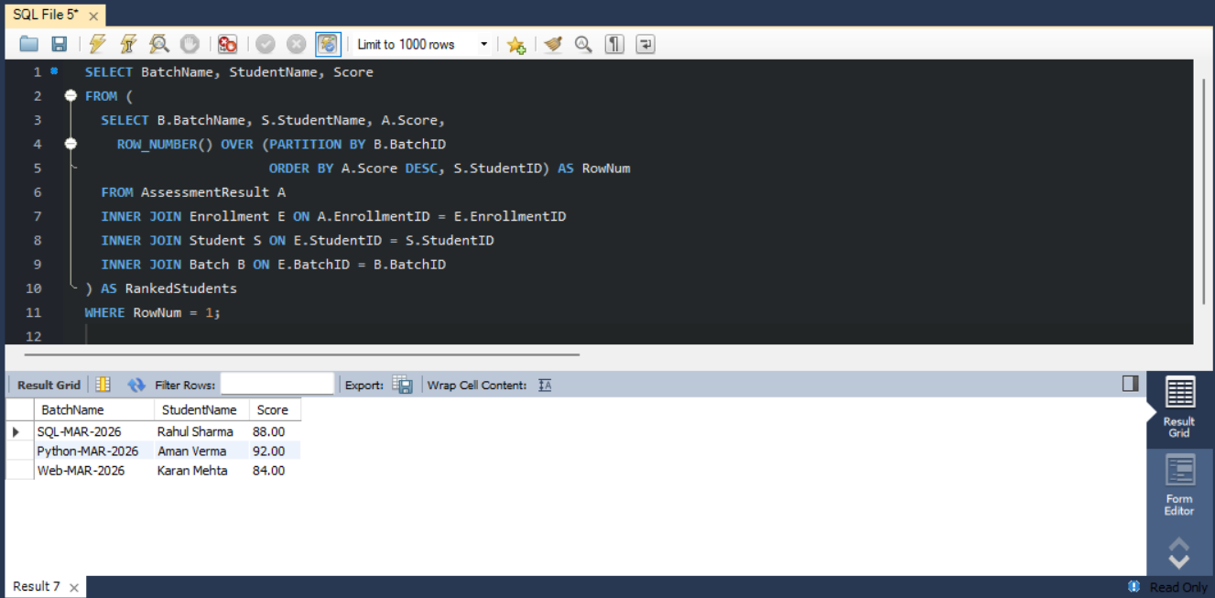
Q8. Display students who have not attended any session.
SELECT S.StudentID, S.StudentName
FROM Student S
WHERE NOT EXISTS (
SELECT 1
FROM Enrollment E
INNER JOIN Attendance A ON E.EnrollmentID = A.EnrollmentID
WHERE E.StudentID = S.StudentID
AND A.Status = 'Present'
);
Note: As written, this lists students with no attendance records at all. To list students with no Present record, add AND A.Status = 'Present' inside the subquery.
Output:
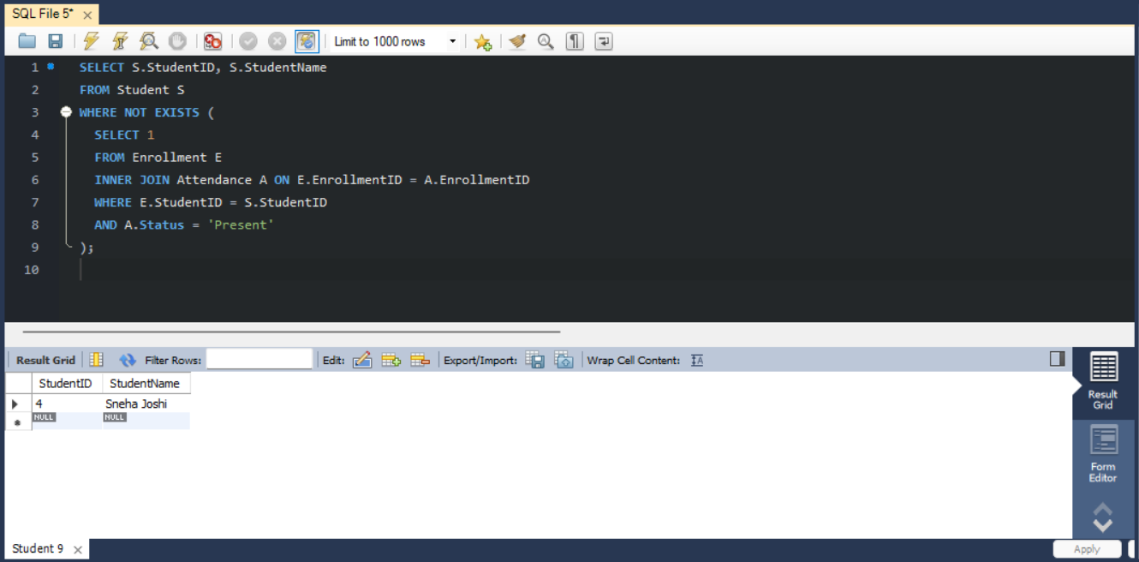
Q9. Compare course-wise student performance.
SELECT C.CourseName,
COUNT(DISTINCT E.StudentID) AS TotalStudents,
ROUND(AVG(A.Score), 2) AS AverageScore
FROM Course C
LEFT JOIN Batch B ON C.CourseID = B.CourseID
LEFT JOIN Enrollment E ON B.BatchID = E.BatchID
LEFT JOIN AssessmentResult A ON E.EnrollmentID = A.EnrollmentID
GROUP BY C.CourseID, C.CourseName;
Output:
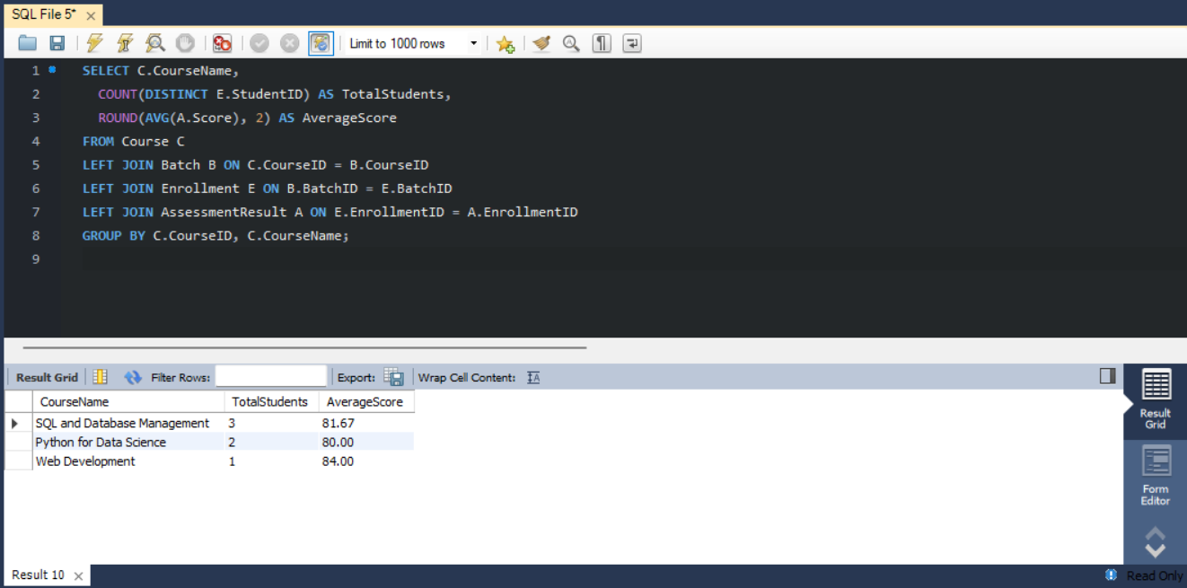
Q10. Rank students according to assessment results.
SELECT S.StudentName, B.BatchName, A.Score,
RANK() OVER (ORDER BY A.Score DESC) AS OverallRank
FROM AssessmentResult A
INNER JOIN Enrollment E ON A.EnrollmentID = E.EnrollmentID
INNER JOIN Student S ON E.StudentID = S.StudentID
INNER JOIN Batch B ON E.BatchID = B.BatchID;
Output:
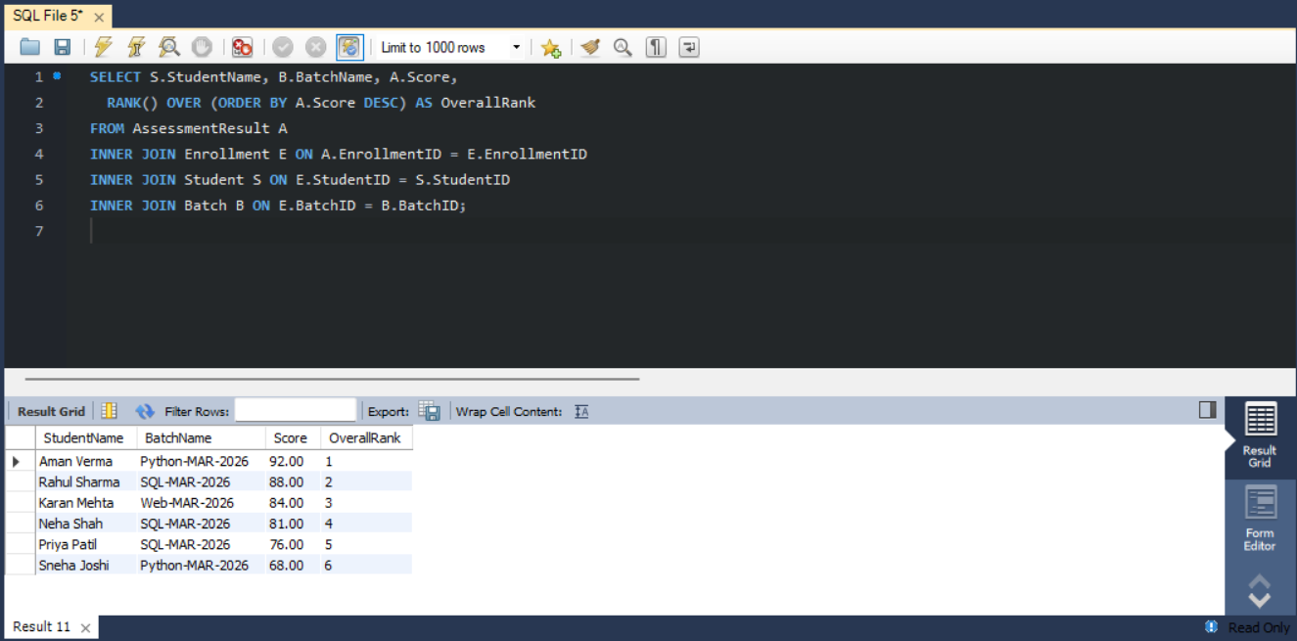
Q11. Find batches with the highest and lowest average attendance.
SELECT B.BatchName,
ROUND(100.0 * SUM(A.Status = 'Present') / COUNT(A.AttendanceID), 2) AS AttendancePercentage
FROM Batch B
INNER JOIN Enrollment E ON B.BatchID = E.BatchID
INNER JOIN Attendance A ON E.EnrollmentID = A.EnrollmentID
GROUP BY B.BatchID, B.BatchName
ORDER BY AttendancePercentage DESC;
Note: First row = highest attendance, last row = lowest.
Output:
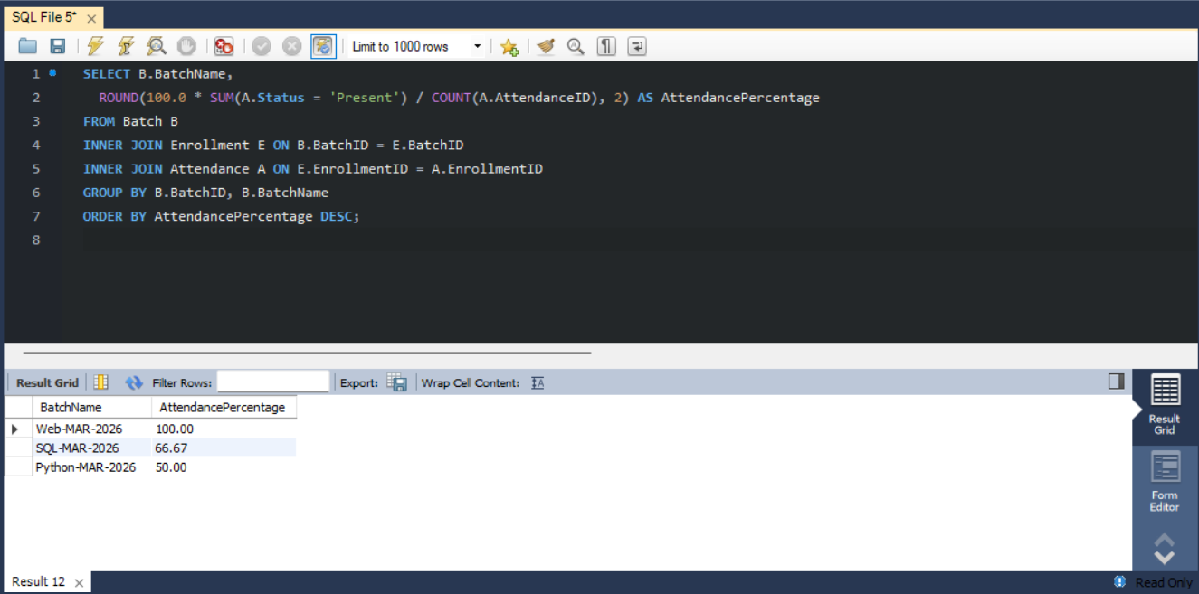
Q12. Generate a student-wise training progress report.
SELECT S.StudentName, C.CourseName, B.BatchName,
ROUND(100.0 * SUM(A.Status = 'Present') / COUNT(A.AttendanceID), 2) AS AttendancePercentage,
ROUND(AVG(R.Score), 2) AS AverageAssessmentScore
FROM Student S
INNER JOIN Enrollment E ON S.StudentID = E.StudentID
INNER JOIN Batch B ON E.BatchID = B.BatchID
INNER JOIN Course C ON B.CourseID = C.CourseID
LEFT JOIN Attendance A ON E.EnrollmentID = A.EnrollmentID
LEFT JOIN AssessmentResult R ON E.EnrollmentID = R.EnrollmentID
GROUP BY S.StudentID, S.StudentName, C.CourseName, B.BatchName;
Output:
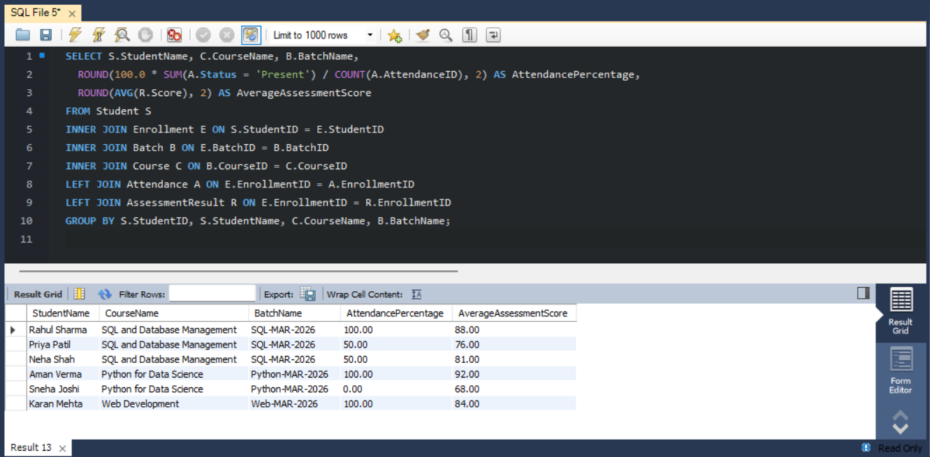

6. Useful View for Management Reporting
StudentProgressView
CREATE VIEW StudentProgressView AS
SELECT S.StudentID, S.StudentName, C.CourseName, B.BatchName,
ROUND(100.0 * SUM(A.Status = 'Present') / COUNT(A.AttendanceID), 2) AS AttendancePercentage,
ROUND(AVG(R.Score), 2) AS AverageAssessmentScore
FROM Student S
INNER JOIN Enrollment E ON S.StudentID = E.StudentID
INNER JOIN Batch B ON E.BatchID = B.BatchID
INNER JOIN Course C ON B.CourseID = C.CourseID
LEFT JOIN Attendance A ON E.EnrollmentID = A.EnrollmentID
LEFT JOIN AssessmentResult R ON E.EnrollmentID = R.EnrollmentID
GROUP BY S.StudentID, S.StudentName, C.CourseName, B.BatchName;

SELECT * FROM StudentProgressView;
Output:
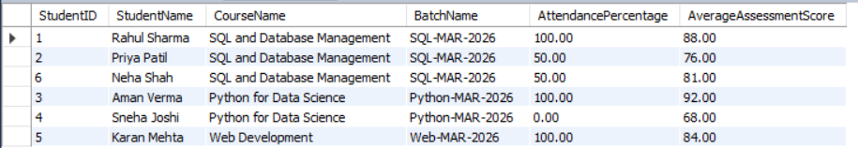

7. Short Report
7.1 Objective
To design and implement a MySQL database for a training institute that manages students, trainers, courses, batches, enrollments, attendance and assessment results, and to use SQL queries to produce reports that support management decisions.
7.2 Relationships
- Course → Batch (one-to-many): a course can run in several batches.
- Trainer → Batch (one-to-many): a trainer can handle several batches.
- Student → Enrollment and Batch → Enrollment (one-to-many each): Enrollment links students to batches, so a student can join many batches and a batch holds many students.
- Enrollment → Attendance and Enrollment → AssessmentResult (one-to-many each): every attendance record and score belongs to one student in one batch.
7.3 Analysis
The figures below are what the business queries return on the sample data in this document (6 students, 3 trainers, 3 courses, 3 batches).
- Enrollment: the SQL batch has 3 students, the Python batch 2 and the Web batch 1.
- Attendance: batch attendance is 66.67% (SQL), 50.00% (Python) and 100.00% (Web). Three students are below 75%: Priya Patil (50%), Sneha Joshi (0%) and Neha Shah (50%).
- Performance: average scores are 81.67 (SQL), 80.00 (Python) and 84.00 (Web). The top scorers are Rahul Sharma (88, SQL), Aman Verma (92, Python) and Karan Mehta (84, Web).
- Ranking: Aman Verma ranks first overall with 92 and Sneha Joshi last with 68.
- Q8: returns no rows, because every student has at least one attendance record.
7.4 Insights
- Highest enrollment: SQL and Database Management has the most students (3 of 6).
- Python batch needs support: it has the lowest attendance (50%) and the widest score gap (92 vs 68). Sneha Joshi attended no session and has the lowest score.
- Attendance and scores: low attendance generally goes with lower scores (Sneha 0% / 68, Priya 50% / 76), although Neha Shah (50% / 81) is an exception.
- Web batch: best attendance and highest average, but it has only one student, so the result is not conclusive.
- Use of reports: attendance percentages, rankings and batch toppers help identify students who need extra training and those who deserve recognition.
7.5 Conclusion
The Training Institute Management System stores institute data in related tables with primary and foreign keys, which keeps the data consistent. The queries (joins, grouping, subqueries and window functions) and the StudentProgressView give coordinators ready reports on enrollment, attendance and performance, and the results point to where additional support is needed. The design can be extended with more batches, assessments and fee records.

8. Brief Explanation of Important Business Queries
Query | What it does | SQL concept
Q1 | Lists each batch with its enrolled students, sorted by batch and name. | INNER JOIN, ORDER BY
Q2 | Shows the course and trainer assigned to every batch. | INNER JOIN (3 tables)
Q3 | Counts students per course through Batch; LEFT JOIN keeps courses with no students (count 0). | LEFT JOIN, COUNT, GROUP BY
Q4 | Groups enrollments by batch and keeps batches with more students than a threshold. | GROUP BY, HAVING
Q5 | Calculates attendance % (Present sessions ÷ total sessions) per student and keeps those below 75%. | SUM(condition), ROUND, HAVING
Q6 | Finds the average assessment score of each batch. | AVG, GROUP BY
Q7 | Numbers students within each batch by score and keeps number 1, the batch topper. | ROW_NUMBER, PARTITION BY, subquery
Q8 | Finds students with no attendance record at all. | NOT EXISTS, correlated subquery
Q9 | Compares courses by number of distinct students and average score. | COUNT(DISTINCT), AVG, LEFT JOIN
Q10 | Ranks all students by score; equal scores share a rank. | RANK() OVER
Q11 | Computes attendance % per batch in descending order; first row is highest, last is lowest. | Aggregation, ORDER BY
Q12 | Combines attendance % and average score for each student with course and batch names. | Multi-table JOIN, aggregation
View | Saves the Q12 report as StudentProgressView so it can be queried like a table. | CREATE VIEW

